LIMU & MONA – BAX

Multi-Client Singapore

LIMU & MONA
Requirements Doc
Ver 1.01

Review and Sign off

The following parties have confirmed and reviewed the specifications presented in this document against selected business processes.

Contents are subjected to change pending further review and revision of this document

BAX Review List |  | Version 1.00
Name | Title | Signature/Date
Dennis Low | Project Manager
Hazel Han | Senior Information Analyst
Tang Boon Onn | System Analyst
Allan Lee | Operations Manager

Revision List
Author | Date | Version | Description
Hazel Han | 15 Sep 06 | 1.01 | Shipment Order Maintenance  - Amended POD to use OrdersExt Notes 1. This is due to POD status being entered much later after ship wave. Flag1 is not editable after ship wave.  - Amended Remarks to be maintained on a per SO basis in External Notes

System Requirements
All core system requirements are satisfied by the EXCEED system and AGEL Hub unless otherwise specified.

- Consignee/Customer Address Setup
Address will be setup in Exceed under the Storer module. Type will be of ‘Consignee/Customer’.
The current Hub Module ‘ShipTo Details’ will not be used.

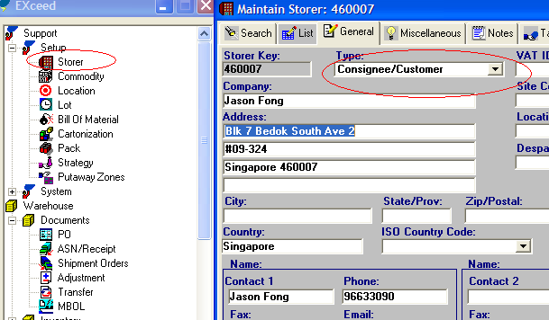

- Pack Key Setup
For most skus, 4 pieces made up a carton, except for distributor kits.
As such, pack key will have to be setup in Exceed to define how many pieces (Each) to a carton.
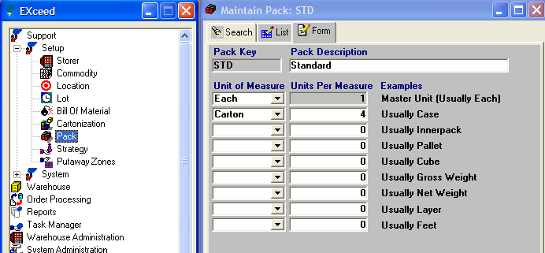

- Commodity Setup
For skus of non-standard pack key, the pack key will have to be defined in Exceed.
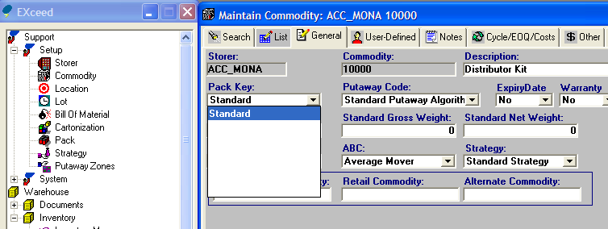

- Shipment Order Maintenance
Shipment Order is maintained in EXCEED.
Specific fields used for the programs are outlined as below:

- SO No.
Different orders for the same consignee are often consolidated under an order in Exceed to improve efficiency in processing. Therefore, 2 order details of an order may have different shipper’s shipment order no. (SO No.) The ‘Externlineno’ in Shipment Order Screen is used to maintain the SO No.
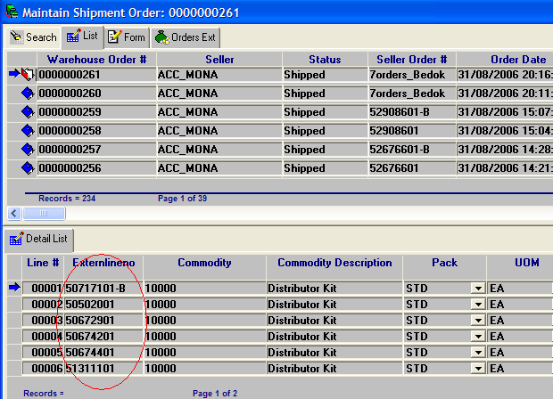

The Hub shall:
- allow searching of an Order based on the SO No.
- display SO NO. in the Pick Ticket Report
- display SO No. in the Delivery Order
(also include showing the Total no. of Pallet and Carton in the DO and removal of AGEL Icon)

Assumption: The SO No. will not be more than 10 characters.

- Delivery Address
The delivery address for the Shipment can be lookup from the Consignee Section of the Shipment Order in Exceed..
Lookup will be based on Consignee/Customer address being setup as described in Item 1 above.
Alternatively, Consignee Code (Storer Key) can be entered and address will be populated automatically from the Storer Setup.

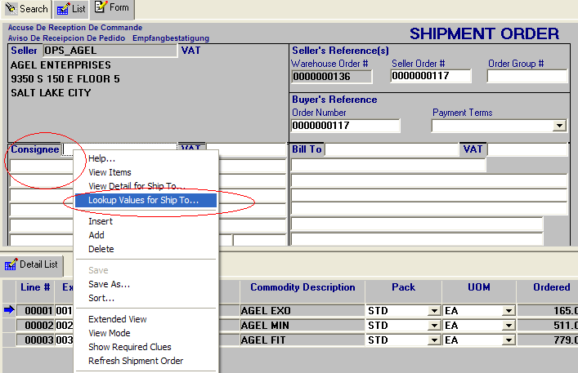

- POD
The Proof of Delivery of the Shipment will be maintained under Notes1 of the OrdersExt.

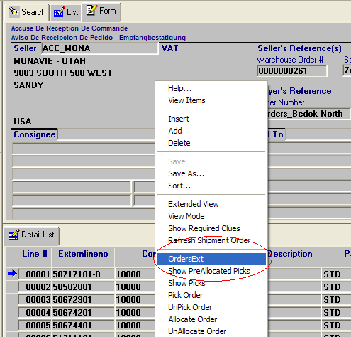

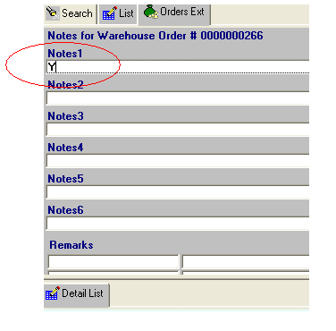

- Remarks
The remarks for the SO will be maintained under Extended Detail View -> First line of the External Note.

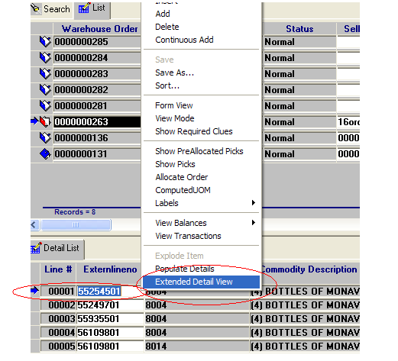
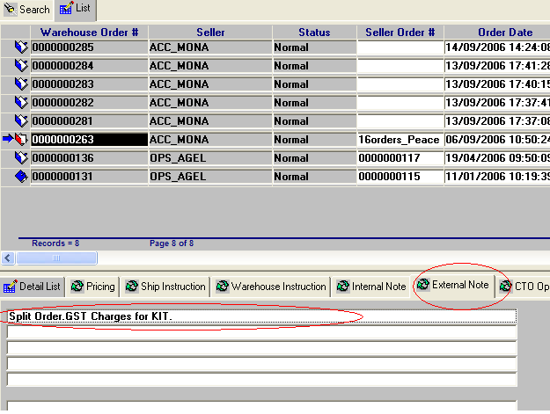

- Shipment Tracking Report
Customer requested an excel spread sheet from BAX to track shipment.
Format is as MonaVie Outbound Tracking Report.xls

The Hub shall:
- allow user to specify the order creation date range for retrieval
- allow user to specify the storer
- allow exporting of the report to excel format
- display the columns as specified in the format above. Mapping are as below:
Report Column | Mapping
No. | Running No.
Order# | SO No.
Delivery Address | Consignee Address for Shipment
Ctc Person | Contact 1 Name and Phone as setup in EXCEED Storer module
Wavekey# | Wavekey of the shipment
Transportation Ref# | Based on ‘Transport Mode’ specified in EXCEED Shipment Order.  If transport mode is Local Delivery - SingPost(LCD), consignement note as specified in packing will be used.  Otherwise (i.e, Internal using vendor such as EastAsia, Ameriod), Wavekey
Transporter | Short Description of ‘Transport Mode’ specified, as maintained in EXCEED Support -> System -> Code, of List Name ‘TRANSMETH’
Local/Export | ‘Local’ if Consignee specified is from ‘Singapore’. Otherwise, ‘Export’
Ctn No. | The total no. of cartons for the SO. No. of cartons will be calculated based on the packkey configured for the sku.
Shipping Date | Ship wave Date
POD | OrdersExt.Notes1
Remarks | First line of External Note for the Order detail

- Inventory Report
An inventory report that shows the following fields is required. The report can be exported to Excel. The report will be retrieved by Storer.
SKU | Lot | Exp Date | Qty on Hand | Qty Allocated | LP | Loc

